Introduction
The OSRO SROS Request for Service System is a web-enabled platform for requesting the following services:
- Blank Electronic Case Report Form (eCRF) review
- Monitoring Visits: Site Assessment Visits, Site Initiation Visits, Close-Out Visits
- Postponement of the next Interim Monitoring Visit
This Request for Service Quick Start Guide provides instructions for submitting blank eCRFs (including requirement specifications) for SROS review.

Accessing the website:
- The website can be accessed via this link Requestor Information · Starter Portal (powerappsportals.com)
- A login is not required for this website. Enter your full name and NIH email.
- For the Service Type, select ‘eCRF.’
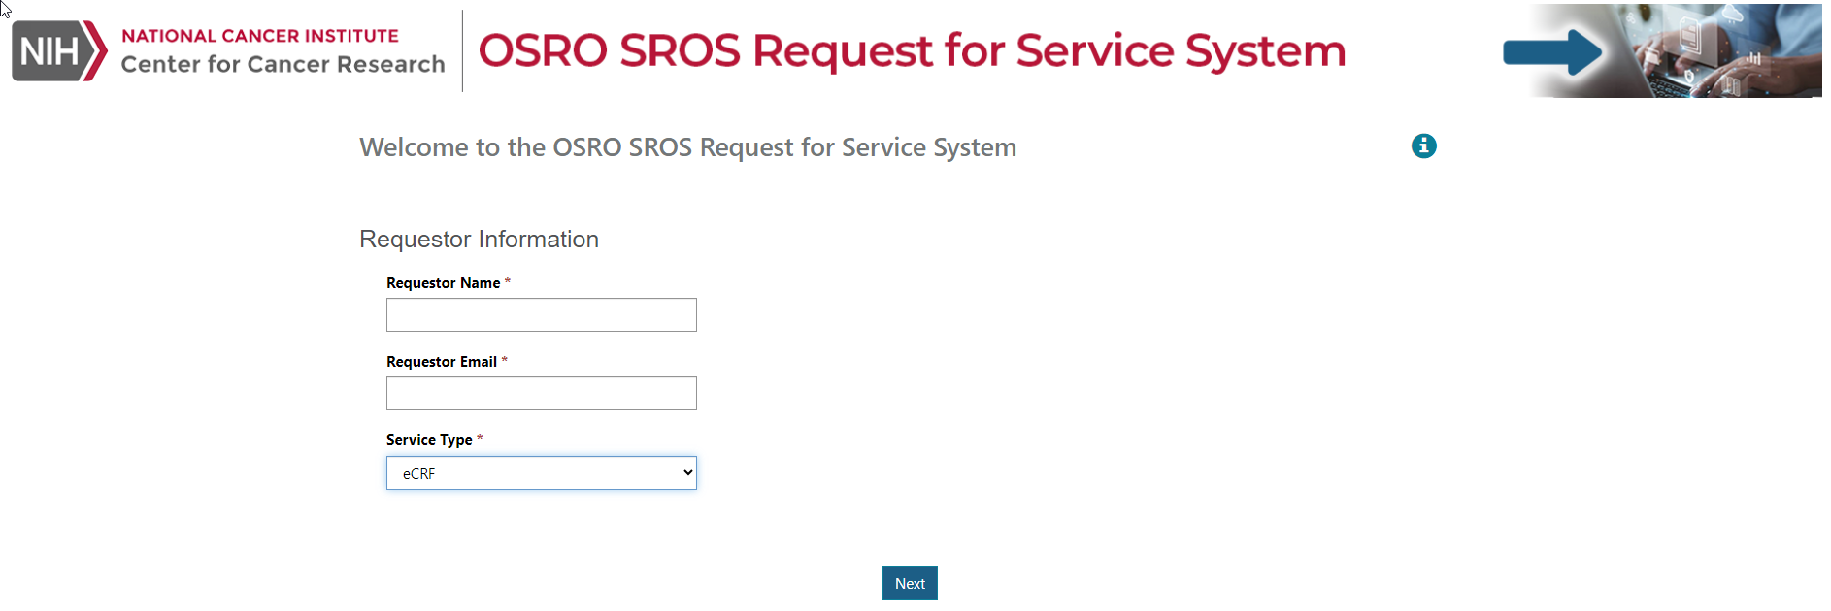
- Click Next to move to the next screen.

eCRF Review Screen:

Enter the required Protocol Number and Protocol Version (Protocol version may be the same as the protocol version date).
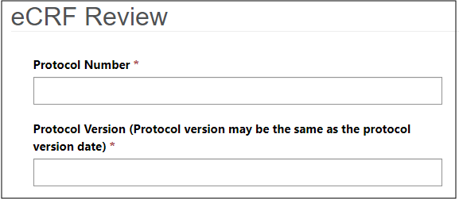

- Select a Protocol Version Date using the calendar icon.
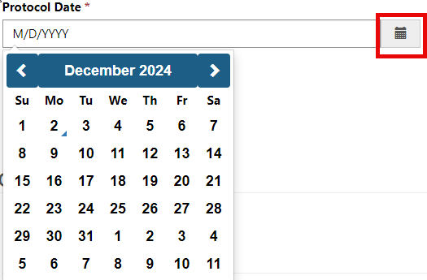

Select eCRF Document Type and then add information in other fields (see below information)

If Requirements Specs is selected from the eCRF Document Type, then the CRF Version, CRF Date and Comments will be non-mandatory fields and can be added if needed.
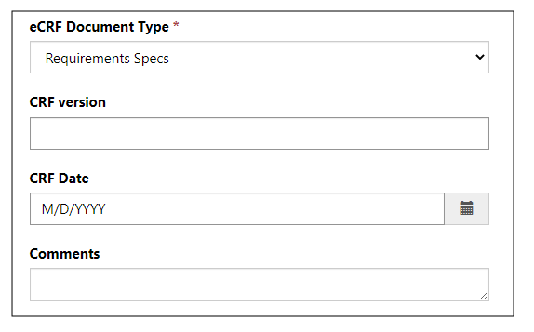
- If ‘Annotated eCRF’ is selected from eCRF Document Type, then the CRF Version and CRF Date will become mandatory field. Comments will be non-mandatory fields and can be added if needed
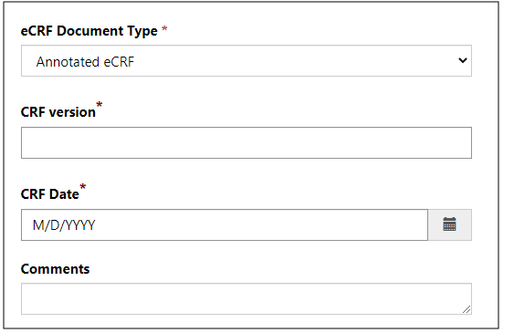
- The CRF Version and date can often be found on the first page of the annotated eCRF.

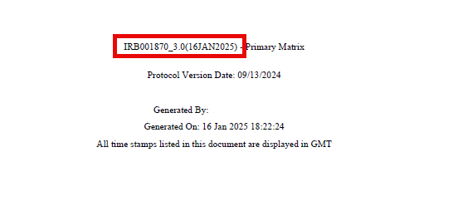

- Click on the Upload Document button.
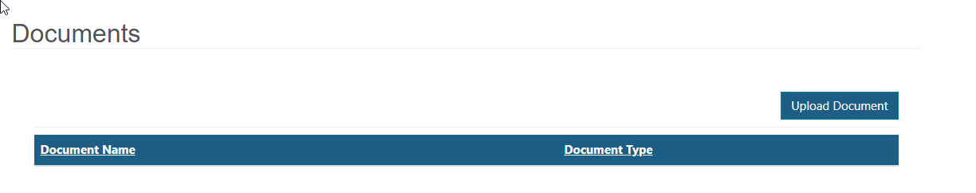

Choose the file and click the Upload button

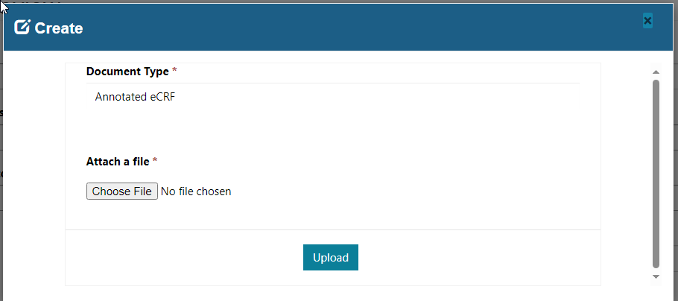

Click Submit. A notification will be displayed on the screen that the request has been successfully submitted. Click the ‘Go Back to Home’ button to enter another request.



Email Notifications:
- An email with the request details will be sent to the requestor and the SROS Monitoring distribution list.

