### Introduction

The OSRO SROS Request for Service System is a web enabled platform for requesting protocol review services for OSRO studies.

### Accessing the site:

* The site can be accessed via this link [Requestor Information · Starter Portal (powerappsportals.com)](https://ncirfs.powerappsportals.com/add-rfs-information/)

1. A login is not required for this site. Enter your full name and NIH email.
2. For the Service Type, select ‘Protocol Review’.

Graphical user interface, application, email



1. Click Next to move to the next screen.

### Protocol Review Screen:

### Enter the required information for Protocol. IND and Comments are optional.

Graphical user interface, application



### Select the Review Type from the drop down. The list includes:

Graphical user interface, text, application



1. Each review type will have a different list of mandatory documents to be uploaded. The expected documents will be displayed on the screen.

Graphical user interface, text, application, email



* When ‘Response to OSRO Review’ is selected from the Review Type dropdown, “No change to document” checkbox will be displayed under each expected document.

*\*Note: If the “No change to document “checkbox is selected, then no document upload is required for that specific document type.*

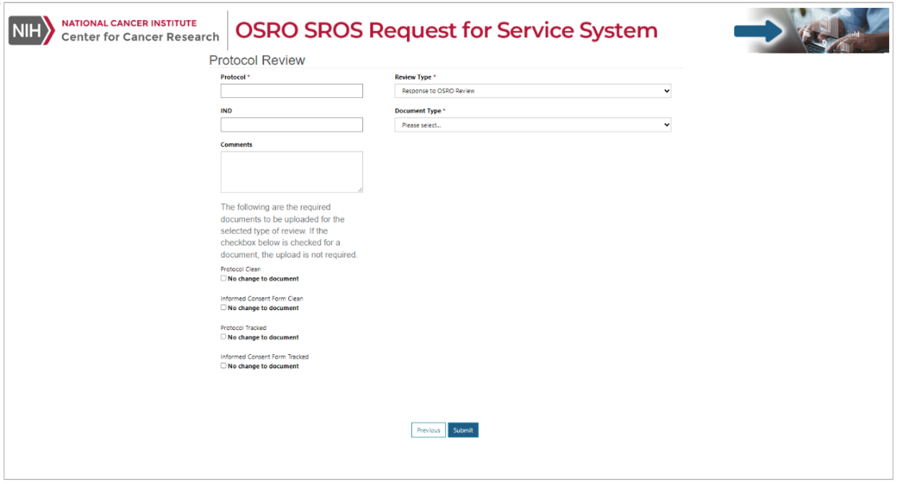

* When “Response to IRB or FDA Stipulations is selected from the Review Type dropdown, “Changes in protocol and/or consent content is based only on IRB Stipulations” optional checkbox shall be displayed .

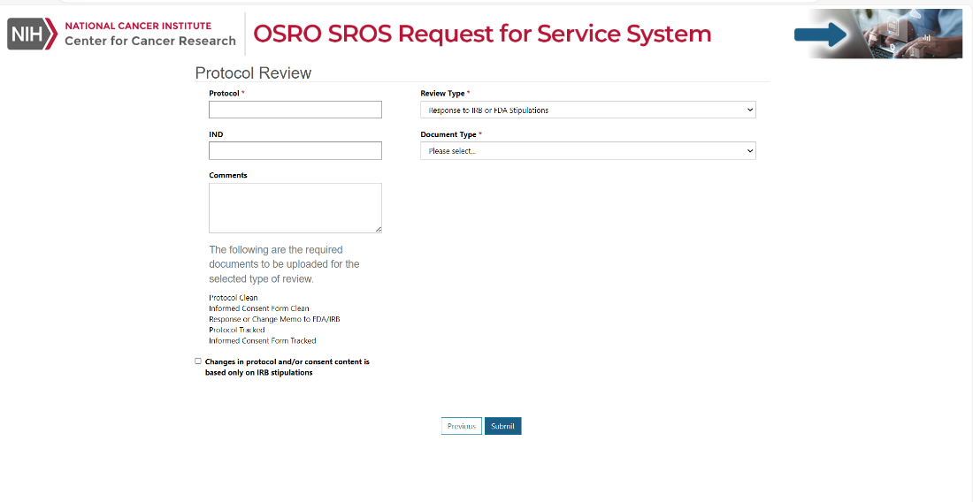

* When “New/Original Protocols” is selected from the Review Type dropdown, the following note will be displayed under the required documents list:

Note: Please upload one of Product Label, Instructions for Use, FDA Package Insert or Investigators Brochure to submit the request successfully.

### Upload Documents:

1. Select a Document Type to upload.

Graphical user interface, text, application, email



1. Click on the Upload Document button.

Graphical user interface, text, application



1. Choose the file and click the Upload button.

Graphical user interface, text, application



1. Upload the remaining required documents. The uploaded documents will be presented in a list. Additional documents may also be uploaded.Graphical user interface, application, email

   
2. If a document needs to be removed from the uploaded list, click on the checkbox, and select Delete.

Graphical user interface, application



### Click Submit. A notification will be displayed on the screen that the request has been successfully submitted. Click on the Back to Home button to enter another request.



### Email Notifications:

* An email will be sent with the request details.