### Introduction

The OSRO SROS Request for Service System is a web enabled platform for requesting Protocol Closure service.

### Accessing the site:

* The site can be accessed via this link [Requestor Information · Starter Portal (powerappsportals.com)](https://ncirfs.powerappsportals.com/add-rfs-information/)

1. A login is not required for this site. Enter your full name and NIH email.
2. For the Service Type, select ‘Protocol Closure’.

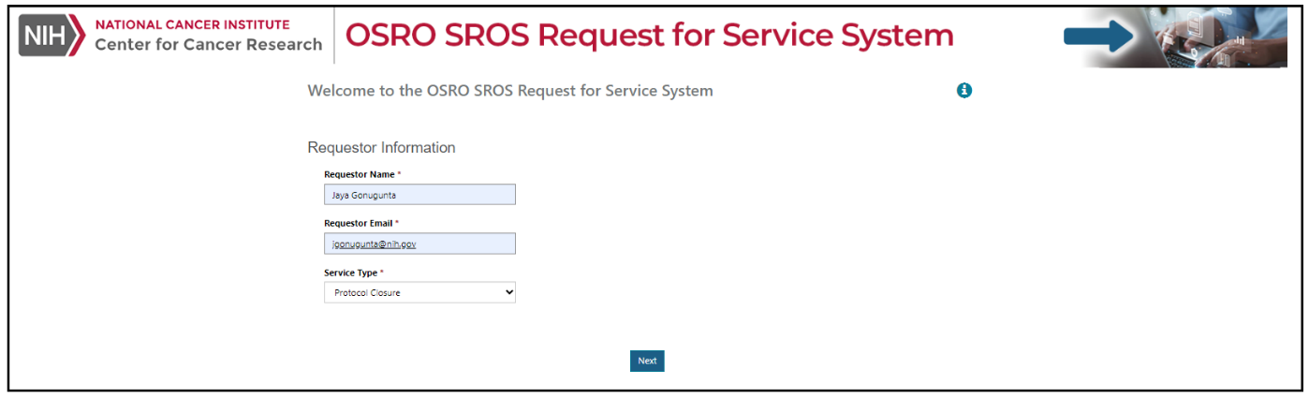

1. Click Next to move to the next screen.

### Protocol Closure Screen:

### Enter the required Protocol, Lead Principal Investigator and select the certify checkboxes.

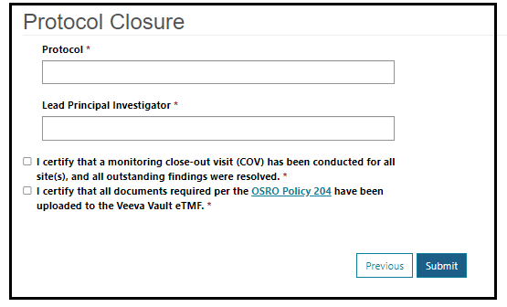

### Click Submit. A notification will be displayed on the screen that the request has been successfully submitted. Click on the ‘Go Back to Home’ button to enter another request.



### Email Notifications:

* An email with the request details will be sent to the requestor and to the SROS Protocol Closure distribution list.