### Introduction

The OSRO SROS Request for Service System is a web enabled platform for requesting monitoring services for Site Initiation Visits, Site Assessment visits, Close-Out Visits and Request to Postpone next Interim Monitoring Visit

### Accessing the site:

* The site can be accessed via this link [Requestor Information  · Starter Portal (powerappsportals.com)](https://ncirfs.powerappsportals.com/add-rfs-information/)

1. A login is not required for this site. Enter your full name and NIH email.
2. For the Service Type, select ‘Monitoring’.

Graphical user interface, application



1. Click Next to move to the next screen.

### Monitoring Screen:

### Enter the required Protocol, Site Name, and Site Address. For the Site Address, indicate the street address and zip code.

Graphical user interface, application



1. If this request is for an internal site, click on the Internal checkbox. An additional mandatory field for Branch will be displayed.

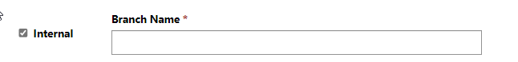

* Select a Visit Type from the Visit Type dropdown:

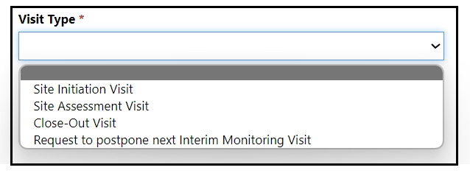

a. When the user selects the Visit Type ‘Site Initiation Visit’:

* + An additional mandatory checkbox is displayed.
  + Mandatory field to enter “Number of In-person Attendees” is displayed.
  + Options to enter preferred dates and times will be displayed. Multiple times may be entered. *Note:* The system requires a date at least 3 weeks after the request date.

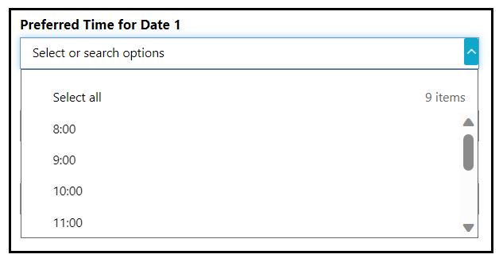

1. When the user selects the Visit Type ‘Site Close-Out Visit’:

* An additional mandatory checkbox is displayed.

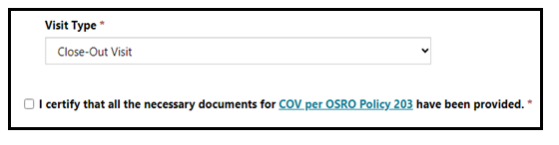

1. When the user selects the Visit Type ‘Request to postpone next Interim Monitoring Visit’:

* A dropdown is displayed with the following options.

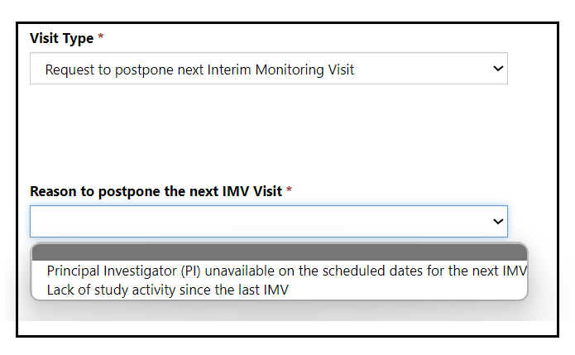

* When the user selects “Lack of Study activity since the last IMV “from the dropdown, additional checkboxes will be displayed.

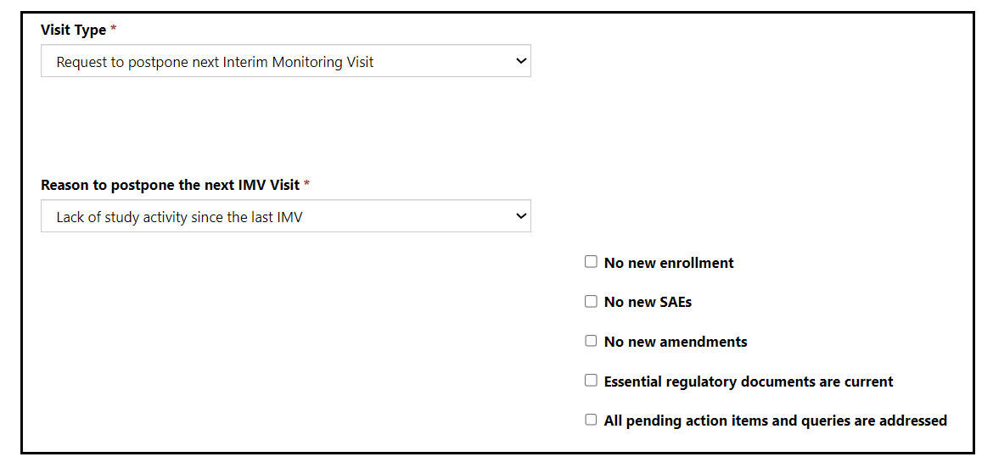

*\*Note: All 5 boxes must be checked to submit a request successfully.*

### Enter the remaining required fields for Site PI and Site Research Nurse. Site Point of Contact fields are optional and can be entered, if the data is available.

Graphical user interface, text, application, email



### Click Submit. A notification will be displayed on the screen that the request has been successfully submitted. Click on the ‘Go Back to Home’ button to enter another request.



### Email Notifications:

* An email with the request details will be sent to the requestor and to the SROS Monitoring distribution list.